HEVER PARISH COUNCIL
(Representing Four Elms, Hever and Markbeech).
Sevenoaks District Council Draft Local Plan Consultation.
September 2018
General Comments;
Members of the Council welcomed the detailed and organised Appendices and online tools. However, the scale and complexity of the information presented, with extremely limited opportunities to view proposals and maps on paper will undoubtedly have limited public accessibility and engagement. There may have been significant groups of the population who would be unable to navigate through the online plans. Holding one event in a busy supermarket car park in Edenbridge was inadequate and timing the consultation over the Summer period unhelpful (for residents and part time clerks). Each parish / town council should have received a paper copy of the Draft plan in its entirety for its use and to share with local residents as required.

SITE HO223 Four Elms road KCC
Members support the principle of a new medical / hospital care facility (with Minor Injury unit) in Edenbridge and secondary school provision (with associated housing).

We support as first choice the HO223 (Kent County Council) plot as is closest to the centre of Edenbridge and may be available at a preferential rate.
It is located closer to the library / community hall etc. (all at the Eden Centre), then the other plots proposed on the Four Elms road or in the South side of Edenbridge. It benefits from good road links and bus and train access to villages – the residents of which will also entirely depend on the hospital / school infrastructure. There is space for staff and visitor parking and allow for any future growth of the town. We understand from previous communications that this area of Edenbridge is the medics preferred site.

  - We would like reassurance that the medical facility would be built at the same time as the housing, not years after.
  - Would need to ensure a clear and permanent buffer / boundary with the countryside and prevent sprawl towards Four Elms.
  - Would require wheelchair access onto both platforms at the train station.
  - Members note the likely impact of this, and other, large scale housing developments (some of which already being built in Edenbridge) on the traffic flow and road safety issues along the B2027 through the heart of Four Elms village. This is the most direct route to Sevenoaks (shopping and other state and private schools) and the impact would be significant at an already risky crossroads in Four Elms village. We would hope to see joined up working with Highways and local Councils and appropriate funding to implement effective road safety measures.
  - Members also would like it noted the impact on inevitable increased demand (and more traffic) on Four Elms and Hever primary schools (of which currently ~80% of children reside in Edenbridge).
  - Affordable housing targets will need to be reviewed in light of the new NPPF targets and also the immediate and projected balance of housing in the town and surrounding villages, to ensure it is balanced and appropriate for local need. Noting that all parishes locally have either already completed or due to complete rural housing needs surveys.
HEVER PARISH COUNCIL
(Representing Four Elms, Hever and Markbeech).
Sevenoaks District Council Draft Local Plan Consultation.
September 2018
SITE HO189 Four Elms Road Coopers Estate
Members support the principle of a new medical / hospital care facility (with Minor Injury unit) in Edenbridge and secondary school provision (with associated housing).

We support as second choice the HO189 (Coopers Estate) plot as is closest to the centre of Edenbridge.

It is located closer to the library / community hall etc. (all at the Eden Centre) than the other plots proposed further East on the Four Elms road or in the South side of Edenbridge. It benefits from good road links and bus and train access to villages - which will also entirely depend on the hospital / school infrastructure. There is space for staff and visitor parking and allow for any future growth of the town. We understand from previous communications that this area of Edenbridge is the medics preferred site.

  - We would like reassurance that the medical facility would be built at the same time as the housing, not years after.
  - Would need to ensure a clear and permanent buffer / boundary with the countryside and prevent sprawl towards Four Elms. Skinners Lane may be an appropriate barrier.
  - Would require wheelchair access onto both platforms at the train station.
  - Members note the likely impact of this, and other, large scale housing developments (some of which already being built in Edenbridge) on the traffic flow and road safety issues along the B2027 through the heart of Four Elms village. This is the most direct route to Sevenoaks (shopping and other state and private schools) and the impact would be significant at an already risky crossroads in Four Elms village. We would hope to see joined up working with Highways and local Councils and appropriate funding to implement effective road safety measures.
  - Members also would like it noted the impact on inevitable increased demand (and more traffic) on Four Elms and Hever primary schools (of which currently ~80% of children reside in Edenbridge).
  - Affordable housing targets will need to be reviewed in light of the new NPPF targets and also the immediate and projected balance of housing in the town and surrounding villages, to ensure it is balanced and appropriate for local need. Noting that all parishes locally have either already completed or due to complete rural housing needs surveys.

HEVER PARISH COUNCIL
(Representing Four Elms, Hever and Markbeech).
Sevenoaks District Council Draft Local Plan Consultation.
September 2018
SITE MX10 Breezehurst Farm, Crouch House road
Members believe that this site on the Western / Southern side of Edenbridge is too remote for a health / education site with inadequate highway / public transport provision, especially for residents of villages such as Hever, Four Elms and surrounds.
Even with the developers proposed traffic lights by the railway bridge on Crouch House road, there are a number of pinch points from the main routes in Edenbridge compounded by residents having to park on the roads, which would cause regular gridlock.

HEVER PARISH COUNCIL
(Representing Four Elms, Hever and Markbeech).
Sevenoaks District Council Draft Local Plan Consultation.
September 2018
SITE MX51 Crouch House road
Members believe that this site on the Western / Southern side of Edenbridge is too remote for a health / education site with inadequate highway / public transport provision, especially for residents of villages such as Hever, Four Elms and surrounds.

There are a number of pinch points from the main routes in Edenbridge compounded by residents having to park on the roads, which would cause regular gridlock and would not be able to cope with significant increases in traffic volume

HEVER PARISH COUNCIL
(Representing Four Elms, Hever and Markbeech).
Sevenoaks District Council Draft Local Plan Consultation.
September 2018
SITE HO364 – Edenbridge and District War memorial hospital

The Council understands that it is registered to NHS Property services and await options from them and health care providers for the future of this site. It is important that the origins and financial history of this site and ownership / responsibility for future plans are clearly established and communicated with the wider community. We support Edenbridge Town Council and Cllr. Clive Pearman in their stewardship of this site in this process.

HEVER PARISH COUNCIL
(Representing Four Elms, Hever and Markbeech).
Sevenoaks District Council Draft Local Plan Consultation.
September 2018
SITE MX44 Romani way, Hever road

The Council were not clear where the evidence is that “community and social infrastructure benefits” are significant or that there is an existing local need that justifies using exceptional circumstances to build on the Green Belt here.

Traffic access from Mead road and Hever road are inadequate and inappropriate to develop further.

There is currently an 80 bed nursing home being built in Edenbridge with no evidence that a similar further care facility required.

Building on the Green Belt for employment purposes is not classed as exceptional circumstances.

Cumulative gypsy provision on this and the Seven Acre site (just a few metres down the road) would make it the largest site in Sevenoaks and wholly inappropriate for this rural border. These two sites being listed in different Appendices in the Draft Local Plan is misleading to the reader and MX44 should have been listed (with explanation) in Appendix 1 & 3.

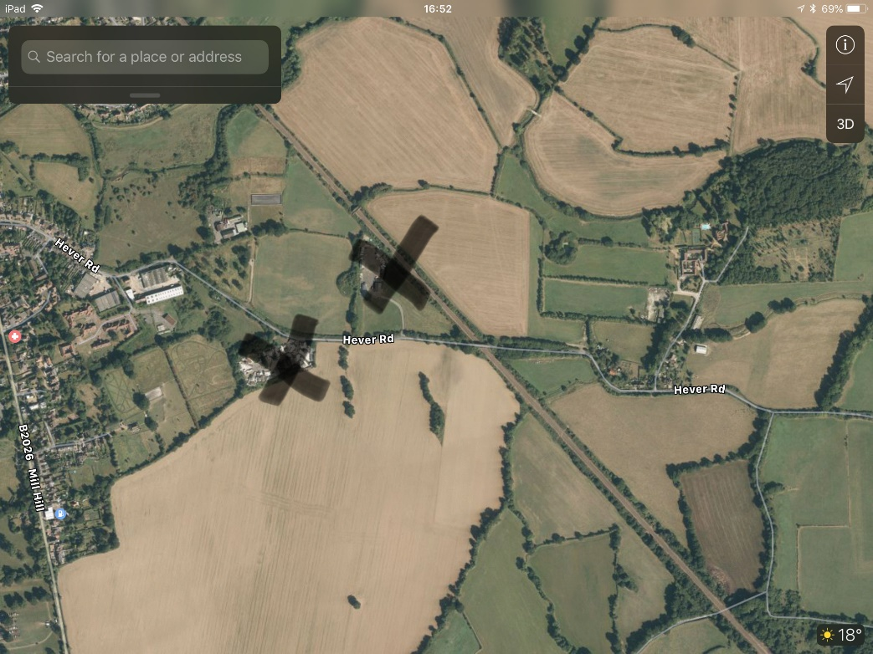

HEVER PARISH COUNCIL
(Representing Four Elms, Hever and Markbeech).
Sevenoaks District Council Draft Local Plan Consultation.
September 2018
SITE GT12 Seven Acre Farm, Hever road

Hever Parish Council maintain their position on this site, which is to object, having last commented on it during the most recent planning application 17/02703/CONVAR, which is summarised below.
Cumulative gypsy provision on this and the Romani Way site (just a few metres down the road) would make it the largest site in Sevenoaks and wholly inappropriate for this rural area. Previous appraisals have evidenced that these sites should have 15 or fewer plots and we request that these sites are considered as one in relation to pitch spaces here, noting the rural location and Green Belt status.

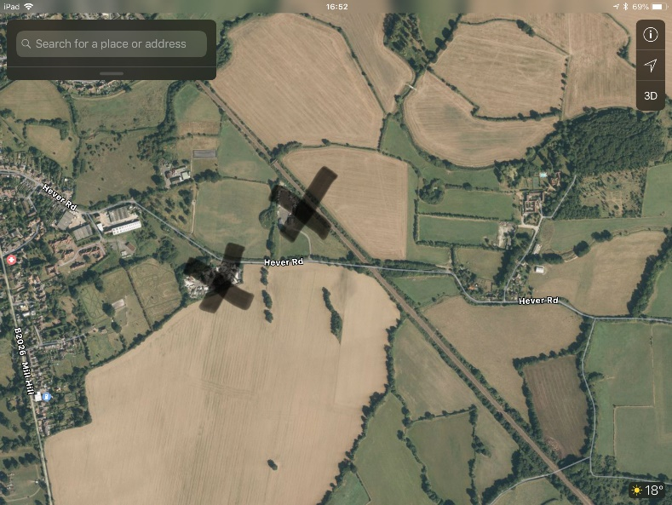

These two sites being listed in different Appendices in the Draft Local Plan is misleading to the reader and MX44 should have been listed in Appendix 1 & 3.

Since the last application, it must be noted that the new NPPF Inspectorate is able to consider retrospective negative planning history in appeals.
(1) Does the definition of gypsy and traveller still apply once in residence for 11 years?
Defined by DCLG Planning policy for traveller sites (August 2015) as “Persons of nomadic habit of life whatever their race or origin, including such persons who on grounds only of their own or their family’s or dependants’ educational or health needs or old age have ceased to travel temporarily, but excluding members of an organised group of travelling show people or circus people travelling together as such”.
The planning policy goes on to state that, “In determining whether persons are “gypsies and travellers” for the purposes of this planning policy, consideration should be given to the following issues amongst other relevant matters: a) whether they previously led a nomadic habit of life b) the reasons for ceasing their nomadic habit of life c) whether there is an intention of living a nomadic habit of life in the future, and if so, how soon and in what circumstances”.
This means that for planning-related purposes the definition of Gypsy and Traveller has been changed so that it excludes those who have permanently ceased from travelling.
(2) Protection of green belt – emphasis is now on protection;
PPTS 2015 The policy sets out the Government’s aims in respect of traveller sites, namely:
“c. to encourage local planning authorities to plan for sites over a reasonable timescale d. that plan-making and decision-taking should protect Green Belt from inappropriate development f. that plan-making and decision-taking should aim to reduce the number of unauthorised developments and encampments and make enforcement more effective.
k. for local planning authorities to have due regard to the protection of local amenity and local environment”.
Paragraph 16 of the Planning Policy for Traveller Sites tightens the very special circumstances for planning applications, noting that subject to the best interests of the child, personal circumstances and unmet need are now unlikely to clearly outweigh harm to the Green Belt and any other harm (so as to establish very special circumstances).

(3) 3 year extension has now lapsed and should be enforced
This use was originally unauthorised before temporary permission was granted on appeal in 2006. SDC granted a further temporary permission in 2010 although this has now expired. The updated NPPG document makes clear that if a site is intentionally occupied without planning permission this would be a material consideration in any retrospective planning application for that site. Whilst this does not mean that retrospective applications will be automatically refused, it does mean that failure to seek permission in advance of occupation will count against the application.
(4) No need for additional pitches – SDC study showed 16th December 2016 and 17th March 2017. From a total of 140 pitches across the District, 8 were vacant.
(5) Density of proposal
Design Guidance (DCLG, 2008) Paragraph 4.47 states that ‘to ensure fire safety it is essential that every trailer, caravan or park home must be not less than 6 metres from any other trailer, caravan or park home that is occupied separately’.
“From the above assessment, I would conclude that the retention of the land as a traveller site would represent inappropriate development within the green belt, with an associated harmful impact upon openness. In addition, there would be some harm to the rural character and appearance of the landscape. However, given that the application is for inappropriate development in the green belt, I do not consider that permission should be granted permanently, but rather for a further period of three years. “2014 A. Byrne 13/02565/FUL
- Since there is only temporary permission, which expired in February 2017, the condition to return it to a green field must be retained. In fact, it should have been returned to green field "within one month following cessation of the use or the expiry of this permission”, therefore this should now be required.
- The road is a country lane with no pavement until it meets the town confines, which would make pedestrian access into the town more difficult.
- No street lighting
- National speed limit of 60mph.

REFERENCES
Gypsies and Travellers: National Planning Practice Guidance (NPPG), Planning policy for traveller sites (PPTS) (first published in March 2012 and updated in August 2015).
DCLG National Planning Policy Framework March 2012 6 DCLG Planning policy for traveller sites March 2012.
Sevenoaks District Local Plan – EN1 Sevenoaks Core Strategy – LO8, SP6, SP8 The National Planning Policy Framework Communities and Local Government – Planning Policy for Traveller Sites (March 2012)
PPTS 2015
Sevenoaks District Gypsy and Traveller and Travelling Showperson - Accommodation Assessment 2017 - the accommodation needs of Gypsies and Travellers to meet the Council’s obligations under section 8 of the Housing Act 1985 (as amended by section 124 of the Housing and Planning Act 2016).

The National Planning Policy Framework, March 2012
DCLG Planning policy for traveller sites, March 2012 (subsequently updated August 2015)

