HEVER PARISH COUNCIL
(Representing Four Elms, Hever and Markbeech).
Local Plan Consultation – “Additional Potential Strategic Development Sites in the Green Belt Consultation”. HO412 / MX62 Land between Hartfield Road and Hever Road, Edenbridge.
Hever Parish Council objects to the inclusion of this site on the following basis;
A Green Belt

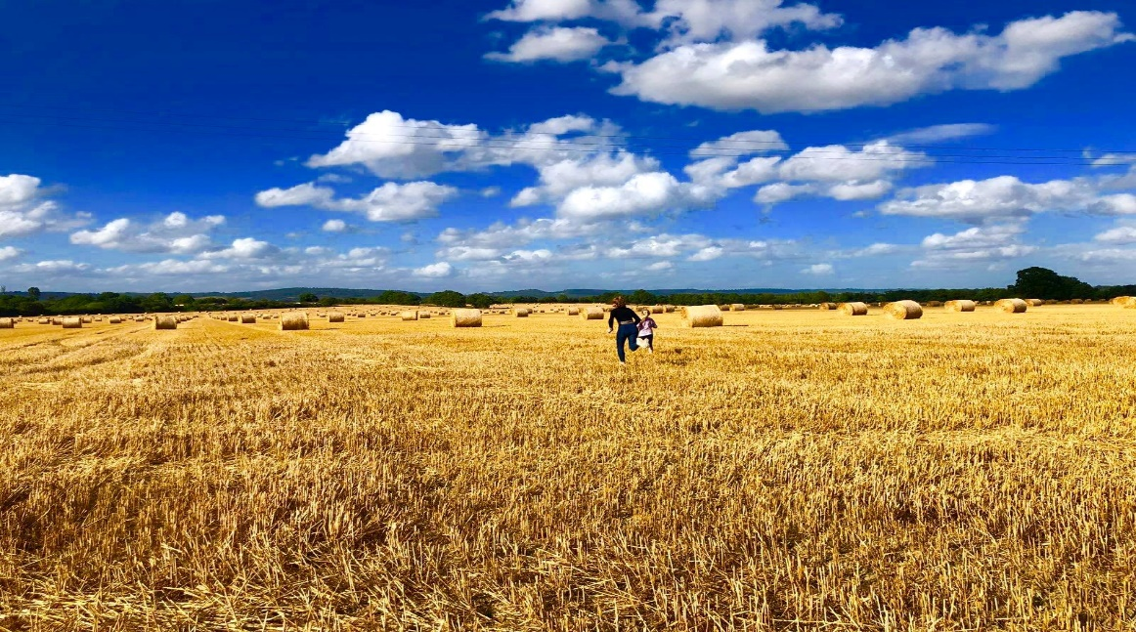
The 2017 Arup reports commissioned by SDC has rated this green belt (both as an area and also as a boundary) as performing “strongly” with the use of the land in green belts having a positive role to play in;
- Retaining attractive landscape, near to where people live
- Secure nature conservation
- Retaining land in agriculture
- Preventing urban sprawl. NPPF 134(a)
This site is adjacent to the High Weald Area of Outstanding Natural Beauty.
SPD Sevenoaks Countryside Assessment (2011) notes the Eden Valley key characteristics as being;
- Flat to gently sloping, open mixed farmland
- Large arable fields
- Seasonally flooded
Mature standard oaks are dotted throughout the landscape. This enables long views to the Greensand ridge to the North and wide views generally over the farmland.
The ancient line of the B2026 (Roman road) also enforces the sense of continuity in the landscape and the flat arable land defines the approaches of the town and represents the major change in the landscape from rural to urban.
The Regulation 19 Consultation Document reinforces the need to “protect, conserve and enhance the Green belt”.
There are no exceptional circumstances to build on the Green Belt here.
B. Location / Access / Transport / Air quality
It is not close to the centre of Edenbridge town (where the density of the population is highest) where is the existing library / shops, community centre (Eden centre) and stations. This proposed site barely borders the existing settlement. Realistically, residents would not walk 25 minutes to access shops / leisure or transport (commuters). Road traffic is the main contributor to poor air quality as there is a high dependency on private vehicles to make journeys to such key locations, so the site is not sustainable.

The proposed site is under the flightpath of Gatwick, where noise and contamination by particulates are considered to cause damage to health by the World Health Organisation.

The surrounding local road network including towards the villages of Marsh Green, Hever and Four Elms are inadequate to allow for the impact on inevitable increased demand (and more traffic) on Four Elms and Hever primary schools (of which currently ~80% of children reside in Edenbridge). Kent County Council have stated that they do not have resources to improve this network.
Hever road is a country lane with no pavement or street lighting until it meets the town confines, which would make pedestrian access into the town unsafe. It has a National speed limit of 60mph.
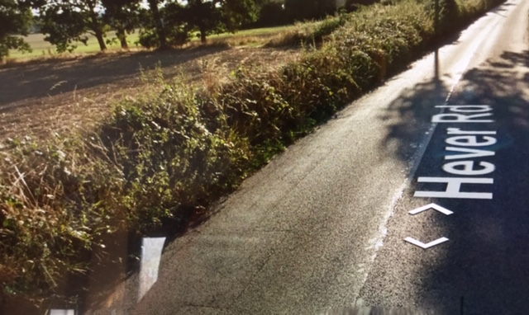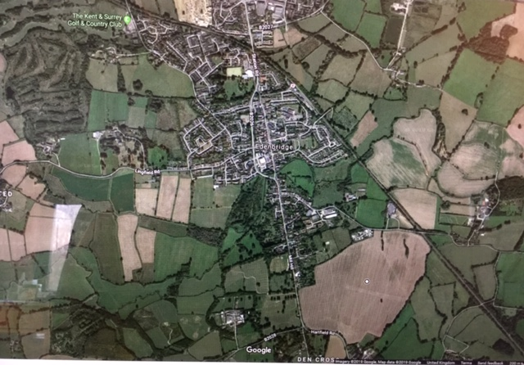
Development should be located across the centre and northern parts of the town, where the building of a large supermarket and home store is underway in addition to the St. John’s housing development and proposed Four Elms road housing.
SDC Proposed Submission Version Chapter 4 states a need to “ensure well connected communities are supported by appropriate infrastructure”.
C. Social / community need
West Kent Clinical Commissioning group have “confirmed no requirement for this site to make provision of a Doctors surgery” and instead have documented a clear preference for the Four Elms road site. It is understood the Health Trust are intending to purchase the KCC site and are currently working towards submitting a full Planning Application in the next 4 months

Hever Parish Council supports instead the development of the site along the Four Elms Road (HO223 / HO 189 / ST2-33 / ST2- 34) for the evidenced needs for a new medical centre and associated housing, which has much better access to public transport (bus and train), particularly for residents in outlying villages.

There is no objectively assessed development and infrastructure requirements for this area and significant community and social infrastructure benefits are not evidenced or met by this proposal. (NPPF 135).
There is currently an 80 bed nursing home being built in Edenbridge with no evidence that a similar further care facility required. There is already a Community Hub to the North of Edenbridge at the Eden Centre.

D. Housing Provision

Edenbridge and surrounding areas have and continue to contribute more than proportionality towards the District wide housing need. With the submitted plans for Four Elms road housing / medical site (240 units), based on an average occupancy of 2.34 persons / dwelling, another ~700 persons on this site is disproportionate to the total for the town.

Affordable housing provision needs to be developed locally and parishes such as Hever, Leigh and Chiddingstone are all in the process of providing local needs housing that genuinely meets the local need.

“For many rural households, finding somewhere affordable in their local community remains a barrier. Small developments of local needs housing schemes can provide affordable housing for local people, thereby enabling them to stay in their community and contribute to village life.”
December 2014, the Rural Housing Alliance

E. Flood Risk / Use of land / Wildlife / Public Access

The rural nature of this area is already criss crossed with Public Rights of Way and it is contradictory to claim to offer a “Country Park” placed on top of publically accessible existing Green Belt. We are washed over with the Green Belt with plenty of “Country” in every direction and there are already parks (formal landscaped and recreational play spaces) in Edenbridge and every village.
It has been identified that it is an important role of the Green Belt to safeguard places for wildlife and nature.
The agricultural land on this site is of high quality.
Additional properties will add pressure to the existing flood zone and there are realistic concerns on the inadequacy of the current systems for both sewage and rain water run-off. The developers suggestions to “build the land up” would only exacerbate the visual alteration of the historic landscape and exacerbate the flood issues on surrounding areas.
Southern Water have commented on the need for reinforcement in order to provide additional capacity, with no such documented plans from the developers.

In summary, having considered the concerns regarding the site deliverability assessment (loss of agricultural land, access difficulties, no necessary community benefits on this site, lack of infrastructure, high flood risk) and the site appraisal conclusion, Hever Parish Council believes this is NOT a suitable site to progress into the SDC Local Plan

