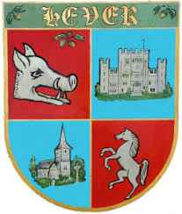
HEVER STATION
Passenger benefit fund
What do passengers want £30,000 to be spent on?

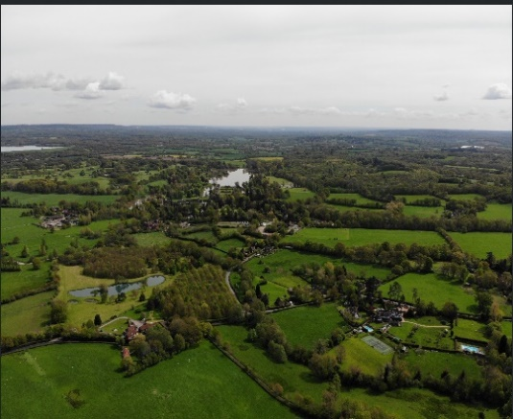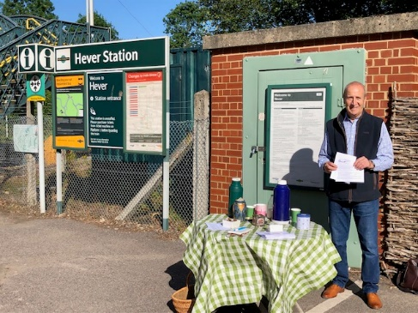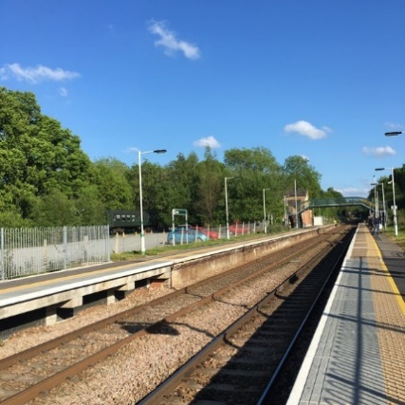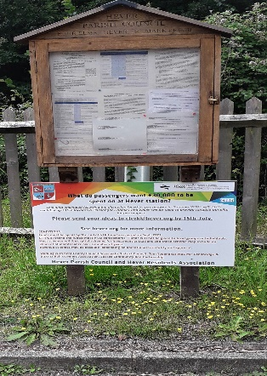

There were 42,948 passenger journeys to / from Hever last year.
Hever Parish Council and Hever Residents Association are active, engaged and the most local stakeholders in this West Kent village.
As groups who regularly work together on many projects for the Hever community we are best placed to promote and identify ideas appropriate and affordable for our station. Hever station is remote, not located near to the village or the major tourist attraction of Hever castle. There are no public transport options and taxis even if called, have to travel a significant distance, with a lengthy delay.

We have liaised with;
Kent County Council, Sevenoaks District Council, Tom Tugendhat MBE MP, Edenbridge and District Rail Travellers Association and the steering group of the Sussex Community Rail Partnership. We have also spoken with Leigh Hopkins, Passenger Benefit Fund engagement team (GTR).

Together, in May, June and July, we have actively engaged rail users & received their suggestions;
- Emailed newsletter to ~250 existing subscribers
- Post on community / parish council website www.hever.org
- Post on Facebook—Hever Parish Council
- Article in The Link Community magazine for July / August (free online and hand delivered to 257 households)
- Professional banners at the station
- Leafleting of cars in station car park (~150 cars on 3 different midweek days)
- Physical presence on platform at peak times to ask for users to vote. This occurred on Monday 1st July (the 7am, 7.30am, 8am, 8.30am and 9am departures from Hever to London) 4th July visit to local pub and returning trains from London to Hever arriving at 6pm, 6.30pm, 7pm. A total of 56 different individuals were consulted on these occasions.

We note that there are no ideas in GTR’s annual station improvement programme that involve Hever station.

Data of Hever station usage over time.

In conclusion, based on the conditions of the fund, the responses received and local knowledge, we wish to propose the following schemes to receive funding from the fund;

- Canopy over the ticket machine
- Landscaping of the platforms (weed removal, native species planting and maintenance)
- Refurbishment of the existing passenger shelters
- Artwork on the platforms to reflect the historic nature of the village
- Additional seating on London bound platform

From discussions with GTR, the following suggestions may not be possible within the remits of this fund, however, we would like to progress ideas for the following by other means;
- Timetabling changes to facilitate the 18.37 train from London bridge to stop at Hever and a later return service from London on Fridays and Saturday’s i.e. that the 11pm train from London Bridge that stops at Edenbridge town, were also to stop at Hever station.
This was by far the most popular suggestion from train users. This may be a revenue generating scheme.
- Works on neighbouring footpaths leading to the station. These are not on GTR land.
- Working with owners of the private station car park. There was, until relatively recently free parking for users at the station. There is a significant capacity for parking here, compared to Cowden station which has congestion issues.
- Improving the bus replacement service – lighting, signage and closer drop off point.
- Working with local businesses to offer a coffee vending service at peak times.

