Welcome to the 3 new Councillors who were co-opted to the vacancies within Hever Parish Council. Thank you to them both for volunteering to represent their villages and the wider community. The parish council consists of 10 Councillors across the 3 villages (Four Elms, Hever and Markbeech) who volunteer their time.
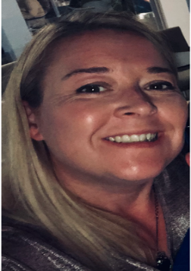Angela Connolly (Four Elms ward)
I have lived in Four Elms for 13 years, I have always commuted to London for work and have been in the Metropolitan Police for 23 years in a variety of different roles. I have a son who attends the Four Elms Primary School.
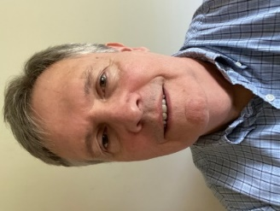Philip Lindsay (Hever ward)
An active member of the community, Philip represents the PC on the Hever Residents Association committee, rings the bells at St Peters, Hever and sings in the choirs occasionally at Hever and Markbeech. Happy to have retired from full time employment after a long career in financial services.

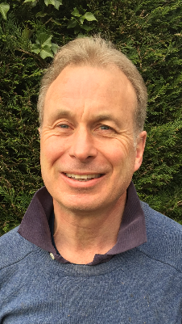 Nick Roberts (Four Elms ward)
I moved from London to Four Elms, with my wife & family, in 2006. Our four children have all been educated locally. I worked in the City of London for over 30 years but retired in June 2017 to focus on charity work, hobbies & interests. I now have a wood workshop where I teach myself carpentry.

March 2021

