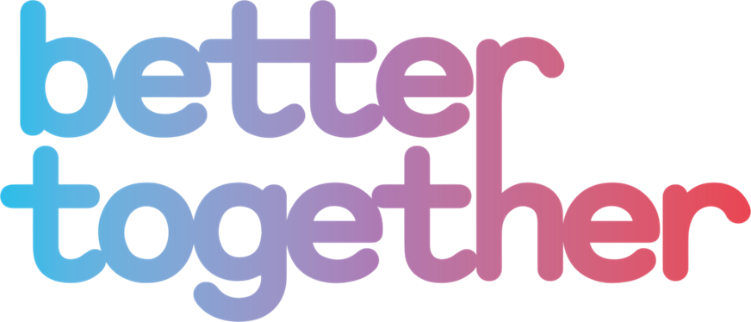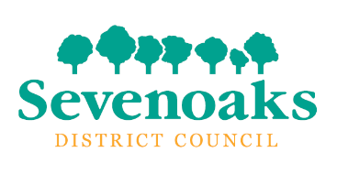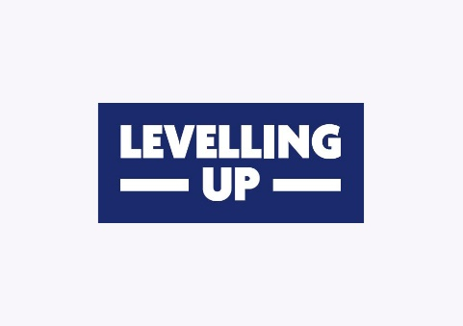

**Better Together**

**Community Mobilisation Fund**

**Guidance Notes and Application Form**

**2023/24**

Better Together builds on the ‘hands on’ projects that people created during the pandemic in their own neighbourhoods.

Community groups play a vital role in supporting and bringing together local people. The Community Mobilisation Fund will help support individuals and new/existing community groups by enabling practical support, such as skills development and capacity building, alongside local activities and events.

If you would like to *do more in your community, for your community*, whether it be sharing skills, spaces and resources, helping families to work and play more together, food growing or community cooking and meals, or perhaps supporting the environment through upcycling or community litter picks, the Community Mobilisation Fund may be able to support you.

**Criteria for funding**

Please read the grant criteria carefully as applications cannot be considered for funding unless they adhere to them.

1. The fund is available for voluntary groups and community groups other not-for-profit organisations providing services within the Sevenoaks District, which benefit residents of the Sevenoaks District.
2. **Applications can be for a maximum of £1,000 for revenue projects.**
3. In special circumstances and where applicants can demonstrate the additional value, projects may be awarded grants over a period of two years.
4. Organisations / projects can submit a maximum of 1 applications in any financial year (April – March.)
5. Applications can only be accepted on the fund’s application form. All questions should be completed and all requested information provided.
6. Partnership projects are encouraged, but the lead agency in terms of accountability must be made clear on the application.

**Community Mobilisation Fund priorities**

In 2023/24, the fund can support new revenue projects which contribute to the below priorities.

|  |  |
| --- | --- |
|  | **Projects up to £1,000 (revenue)** |
| **Priority 1** | Community-led projects addressing local priorities and fostering a sense of local pride |
| **Priority 2** | Tackling isolation and loneliness |
| **Priority 3** | Improving physical and mental wellbeing |
| **Priority 4** | Promoting and encouraging community safety |
| **Priority 5** | Improving the environment or promoting biodiversity and sustainability |

**What can the fund support?**

Projects must achieve **all** of the following:

* Help to deliver at least one of the five priorities identified.
* Provide demonstrable benefits for residents of the Sevenoaks District.
* Provide support and/or services within the Sevenoaks District.
* Be able to provide evidence that the project has achieved its objectives.

**Setting up a new voluntary or community group**

If you are setting up a new voluntary or community group and need support and guidance in setting up a constitution, membership, accounts, policies and training, we are able to deliver consultancy support in partnership with NCVO, worth up to £500.

We will need to understand how your new voluntary or community group will meet local priorities and needs in the Sevenoaks District. Please contact our Health and Communities team for further information at [contact@bettertogethercommunity.org.uk](mailto:contact@bettertogethercommunity.org.uk)

**When can I submit my application and when will I be informed?**

|  |  |
| --- | --- |
| **Deadline for submission** | **Date of Appraisal** |
| 8 September 2023 | 20 September 2023 |

**How are applications assessed?**

* Applications must demonstrate that they meet the criteria for funding.
* The Better Together Fund Appraisal Group is a multi-agency group
* The Better Together Fund Appraisal Group will have delegated authority by SDC to make grant decisions. However, all grant decisions and monitoring will be reported to the Department of Levelling Up, Housing and Communities as part of the UK Shared Prosperity Fund.
* All applications will be appraised against the criteria set out in these guidelines and applicants will be notified as soon as possible.
* Grant payments will be issued in advance of the project commencing as soon as possible after the grant has been approved.

**Conditions of funding**

* Specific evaluation requirements will be set out in the grant offer letter.
* The grant must be used solely for the purpose outlined in the application.
* Any unspent funds must be returned to the Sevenoaks District Council.
* The project should be completed within 12 months of the grant being paid, Due to funding restrictions, extensions cannot be provided.
* The project must recognise the grant from SDC, Better Together and the UK Shared Prosperity Fund in any publicity and logos will be provided for this purpose.
* The project must complete and return an evaluation form to SDC within 6 weeks of the completion of the project, including evidence of expenditure and feedback from beneficiaries.
* The Better Together Fund Appraisal Group reserves the right to suspend a project and recover all or part of the grant in the following situations:
  + Non-compliance with the terms and conditions of the grant as set out in the Guidelines and grant conditions.
  + A fundamental change to the project (as submitted) has been made without the prior consent of the Better Together Fund Appraisal Group.
  + The delivery organisation is no longer capable of delivering the project.

**Sevenoaks District Council**

**Better Together Community Mobilisation Fund**

**Application Form – existing organisations**

1. Name of your organisation

|  |
| --- |
|  |

1. Type of organisation:

|  |  |
| --- | --- |
| Registered Charity - please include number: |  |
| Community Group |  |
| Social Enterprise |  |
| Volunteer Group |  |
| Charity Organisation |  |

1. Are you an existing organisation? If no, please go to question 5. If yes, please confirm that your organisation has the following:

|  |  |
| --- | --- |
| Constitution | Yes/No |
| Bank Account | Yes/No |
| Equality Policy | Yes/No |
| Health and Safety Policy | Yes/No |
| Safeguarding policy that covers children and young people | Yes/No |
| Safeguarding policy that covers vulnerable adults |  |
| Do all staff and volunteers working directly with children, young people or vulnerable adults have Enhanced DBS checks? | Yes / No |

If yes, please provide copies of the documents.

1. Does the organisation have any quality marks or other awards? Please give details here.

|  |
| --- |
|  |

1. Your name and position in the organisation / group

|  |
| --- |
|  |

1. Your contact details

|  |
| --- |
| Address:  Phone:  Email:  Website:  Social Media: |

1. Briefly describe the project which the grant will fund. Include where the project will be delivered, who will benefit and how they will benefit and how you know there is a need for the project (maximum 300 words.)

|  |  |  |
| --- | --- | --- |
| Project start date: |  | |
| Project end date: |  | |
|  | |

1. Please give more details about the people who will benefit from your project:

|  |  |
| --- | --- |
| How many people in total will benefit? |  |
| Will your project be working with a particular age group? Please specify |  |
| Where in the Sevenoaks District will your project be delivered? |  |

9. Finances – please give a breakdown of how the grant would be spent.

|  |  |
| --- | --- |
| Item / Activity | Amount £ |
|  |  |
|  |  |
|  |  |
|  |  |
|  |  |
| Total amount requested (revenue) |  |

If the total cost of your project is greater than the amount requested, please give details of where the other funding will come from and whether or not this has been received.

|  |
| --- |
|  |

1. Which of the agreed priorities will your project help deliver (tick all which apply)

|  |  |  |
| --- | --- | --- |
|  | **Projects up to £1,000 (revenue)** |  |
| **Priority 1** | Community-led projects addressing local priorities and fostering a sense of local pride |  |
| **Priority 2** | Tackling isolation and loneliness |  |
| **Priority 3** | Improving physical and mental wellbeing |  |
| **Priority 4** | Promoting and encouraging community safety |  |
| **Priority 5** | Improving the environment or promoting biodiversity and sustainability |  |

11. Explain how your project will help to deliver the priorities you have ticked above

|  |
| --- |
|  |

12. How will the project involve local people in the running and development of the project or activity?

|  |
| --- |
|  |

13. What changes will the project or activity make that will empower people and enable them to take control of their lives and build resilience?

|  |
| --- |
|  |

14. Equal opportunities - How will you ensure that your project is accessible to all residents who would benefit? Please include information about how you would publicise the project.

|  |
| --- |
|  |

15. How are you going to measure success? You will be asked to identify the success of your project on the project feedback form, so it’s important to think about this now.

|  |
| --- |
|  |

16. Your signature.

This must be the signature of the main contact in question 2.

* I confirm that I am authorised to sign this application on behalf of the organisation named in question 1.
* I confirm that to the best of my knowledge the information in this application form is true and correct.
* If this application is successful, I agree to ensure that the funds are spent as described here.
* I agree to ensure that the organisation complies with all monitoring and other grant conditions.
* I agree to complete and return the final evaluation form.
* I confirm that my organisation will conform to all relevant statutory requirements.

|  |  |
| --- | --- |
| Signed |  |
| Date |  |

Please return your completed application form to Sevenoaks District Council’s Health and Communities team at [communities@sevenoaks.gov.uk](mailto:communities@sevenoaks.gov.uk) by Wednesday 1 March 2023 at 5pm.

This project is funded by the UK Government through the UK Shared Prosperity Fund.