

|  |  |
| --- | --- |
| **Predicted financial position at end of 23/24 year:** | |
| Predicted bank balance at end of year (31/3/24) | £33,137 |
|  |  |
| Amount of CIL monies included in total | £5,401 |
|  |  |
| Balance | **£27,736** |
| Earmarked reserves from 23-24 budget - Infrastructure projects | £9,300 |
|  |  |
| **Predicted Carry forward balance (contingency)** | **£18,436** |
|  |  |
| **Auditors recommend around 20k as contingency so this is a reasonable amount** | |
| Predicted running costs for 23-24 year | £48,800.00 |
| Assumed rate of 3% inflation for 24-25 year | £1,464.00 |
| Grants and donations (assuming same as 23-24) | £4,000.00 |
|  |  |
| Total proposed budget required for 24-25 | £54,264.00 |

**Precept Information**



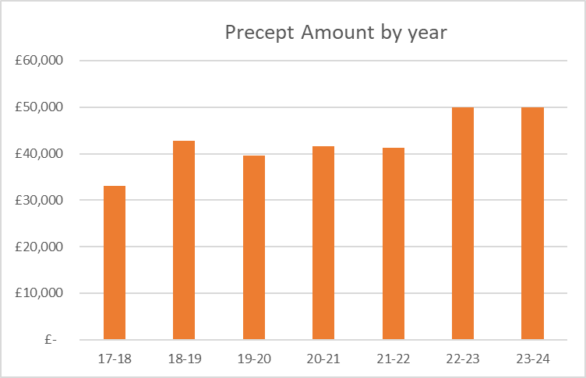

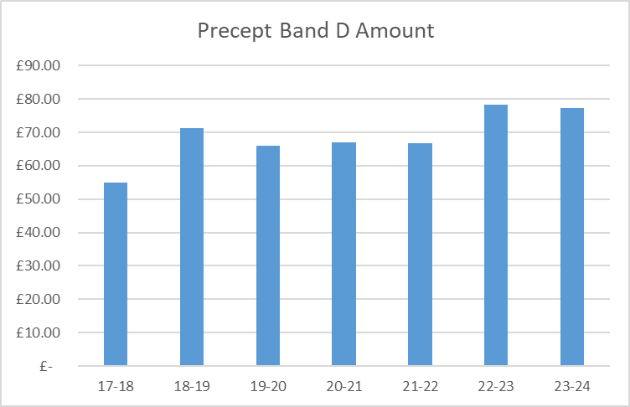

|  |  |  |  |  |  |
| --- | --- | --- | --- | --- | --- |
| **Numbers are for illustration purposes only and assumed 3% increase on Band D Council Tax for 24-25 = £667 per household** | | | £667 |  |  |
| 2024/25 Potential Precept Demand | £51,000 | £52,000 | £53,000 | £54,000 | £54,500 |
| Precept element of Council Tax for Band D | £76.46 | £77.96 | £79.46 | £80.96 | £81.71 |
| Monetry increase in Band D Precept | **-£0.82** | £0.68 | **£2.18** | **£3.68** | **£4.43** |
| *% increase on Band D property Council Tax* | *-1.06%* | *0.88%* | *2.82%* | *4.76%* | *5.73%* |
| Precept as percentage of Band D Council Tax | 11.82% | 12.05% | 12.28% | 12.51% | 12.63% |

**The FEC recommends increasing the Precept to £52,000 for the 24-25 year.**

